**Capstone Project – Sports Analytics**

**Project Overview: Olympic Games Historical Analysis**

This comprehensive project aims to analyse over a century of Olympic Games data to uncover significant trends in sports, events, athlete participation, medal distribution, and regional representation. The primary goal is to provide actionable insights that can improve future Olympics' organization, enhance sports selection processes, and promote global inclusivity across all participating nations.

The analysis encompasses historical data spanning from 1896 to the present day, covering multiple critical dimensions of the Olympic Games. This includes examining the evolution of Summer and Winter Olympics alongside host city patterns, analysing trends in event diversity, gender inclusion, and sport popularity over time. The project also focuses on athlete demographics including age, gender, and nationality distributions, while thoroughly investigating medal distribution patterns by country, sport, and gender. Additionally, it assesses regional representation by examining participation rates and success levels across different nations.

The methodology employs a robust data foundation built from interconnected relational tables including Sport, Event, Games, City, NOC Region, Person, and Medal datasets. Power BI serves as the primary visualization platform, with DAX calculations and SQL/Power Query utilized for advanced data modelling and analysis. The analytical approach systematically examines participation trends over time, compares medal dominance patterns across sports and countries, evaluates progress toward gender parity in both events and participation, and assesses regional disparities in Olympic infrastructure and success rates.

Key focus areas include tracking historical trends in the growth of events, sports, and athlete numbers, monitoring gender evolution and progress toward parity, analysing regional performance patterns including country dominance and underrepresentation issues, and investigating the correlation between hosting Olympics and medal success15. The project deliverables consist of an interactive Power BI dashboard that visualizes trends in participation, medals, and regional performance, a comprehensive report detailing findings, data sources, and methodologies, and a strategic presentation offering actionable recommendations for enhancing diversity, athlete development, and global engagement in future Olympic Games.

THE PROCESS

**Sports Analytics Project Methodology**

**1. Data Acquisition from GitHub:**

Obtain the requisite dataset from a designated GitHub repository, containing comprehensive information on Olympic Games sports analytics, encompassing athlete demographics, medal distributions, event participation, regional representation, and historical performance data across multiple Olympic editions.

**2. Data Transformation and Enhancement:**

If necessary, execute data transformation procedures to ensure data quality and consistency in sports data. Additionally, consider augmenting the dataset with new analytical problem statements to enrich the sports analytics potential, including gender parity analysis, regional performance trends, and athlete demographic insights.

**3. Connecting with Tools:**

Establish connections between the sports dataset and various analytical tools. Interface the Olympic Games dataset with Power BI, Excel, and MySQL Workbench, facilitating seamless sports data integration and processing for comprehensive athletics analysis.

**4. Problem Statement Solution in Power BI:**

Utilize Power BI to delve into the specified sports analytics problem statements. Employ its robust features for sports data visualization, exploration, and analysis, effectively deriving insights and solutions related to medal trends, athlete participation patterns, regional dominance, and Olympic Games evolution.

**5. Exploratory Data Analysis (EDA):**

Perform exploratory data analysis using either Excel or SQL Workbench, depending on the complexity of the sports analytics requirements. Extract meaningful patterns, relationships, and trends from Olympic data to inform subsequent decision-making regarding athlete development, sports selection, and regional representation strategies.

**6. Creation of Visual and Insightful PowerPoint:**

Develop a comprehensive PowerPoint presentation that encapsulates the sports analytics project's objectives, methodologies, problem statement solutions, and key visualizations. Each sports-related problem statement should be accompanied by a dedicated section with pertinent conclusions and insights regarding Olympic performance trends.

**7. Detailed Documentation:**

Compile a detailed report that meticulously documents the entire sports analytics project lifecycle. Include sections on sports data collection, transformation, problem statement formulation, tools integration, Power BI solutions, EDA insights, and PowerPoint visualizations focused on Olympic Games historical analysis and performance metrics.

**Objective: Olympic Games Sports Analytics**

Olympic Games data represents a comprehensive record of athletic excellence, international participation, and sporting evolution spanning over a century. However, there are significant complexities in analysing this data, including variations across sports disciplines, regional representation disparities, historical trends in participation, and the impact of socio-economic factors on athletic success.

The objective of this project is to conduct an exhaustive analysis of the Olympic Games dataset to explore patterns, trends, and factors influencing athletic performance, participation, and medal distribution across different sports, regions, and time periods. The goal is to provide insights that can be used to enhance athlete development programs, improve regional representation, and foster greater inclusivity in Olympic sports worldwide.

The project will involve the following tasks:

* Performing a comprehensive analysis of Olympic participation, including variations across sports and seasons, key factors influencing medal success, historical trends in athlete demographics, and the impact of regional disparities on Olympic performance.
* Deriving meaningful conclusions and recommendations for improving sports development programs, enhancing gender parity, and promoting global athletic excellence.
* Compiling analysis results, conclusions, and recommendations for Olympic committees, sports organizations, and athletic development stakeholders.

The success of the project will be measured by the following metrics:

* The quality of the sports analytics and data visualization
* The relevance of the insights for athletic development
* The impact of the recommendations on future Olympic planning

This project is significant because it has the potential to improve athletic development and promote greater inclusivity in Olympic sports worldwide. By understanding the factors that influence Olympic success and participation patterns, sports organizations can better position their athletes and programs to succeed on the international stage while fostering global sporting excellence and diversity.

**Significance of Sports Analytics Project**

Sports analytics is transforming the Olympic landscape by providing powerful insights for athletes, coaches, sports organizations, and fans. By deeply analysing Olympic data—including athlete performance, participation trends, medal distribution, and regional representation—stakeholders can make smarter, data-driven decisions that enhance training, strategy, and resource allocation.

For athletes and coaches, sports analytics enables personalized training programs, injury prevention, and real-time performance optimization. By examining detailed metrics, they can identify strengths, address weaknesses, and maximize competitive potential, leading to improved results and longer athletic careers.

Sports organizations and national committees benefit from analytics by identifying talent, tracking progress, and making evidence-based decisions about team selection and investment. Analytics also supports fair play, gender inclusion, and global representation by highlighting disparities and progress across nations and sports.

Fans and the broader public gain a richer, more engaging Olympic experience through accessible data visualizations, real-time statistics, and deeper stories about athletes and events. Technology integration—such as wearables, AI, and advanced dashboards—further enhances engagement and transparency, bringing fans closer to the action and the athletes they support.

Policymakers and Olympic organizers use analytics to inform decisions that promote fairness, inclusivity, and sustainability. By tracking long-term trends in gender parity, regional participation, and performance disparities, analytics help shape policies that foster diversity, equal opportunity, and the responsible growth of the Games.

Ultimately, this project empowers all stakeholders to foster excellence, inclusivity, innovation, and legacy in the Olympic movement, ensuring that the Games continue to inspire, unite, and benefit people worldwide for generations to come.

Data Dictionary

**Sport Table**

* **Fields:**
  + sport_id: Unique identifier for each sport.
  + sport_name: Name of the sport (e.g., Athletics, Swimming).

**Event Table**

* **Fields:**
  + event_id: Unique identifier for each event.
  + event_name: Name of the event (e.g., 100m Freestyle).
  + sport_id: Foreign key referencing sport_id in the Sport table.
  + gender: Gender category for the event (Men, Women, Mixed).

**City Table**

* **Fields:**
  + city_id: Unique identifier for each city.
  + city_name: Name of the city.
  + country: Country where the city is located.

**Games Table**

* **Fields:**
  + games_id: Unique identifier for each Olympic Games edition.
  + year: Year in which the Games were held.
  + season: Summer or Winter.
  + host_city_id: Foreign key referencing city_id in the City table.

**Games City Table**

* **Fields:**
  + games_id: Foreign key referencing games_id in the Games table.
  + city_id: Foreign key referencing city_id in the City table.

**NOC Region Table**

* **Fields:**
  + noc_code: National Olympic Committee code.
  + region: Name of the region or country.
  + country: Name of the country.

**Person Table**

* **Fields:**
  + person_id: Unique identifier for each athlete.
  + name: Athlete’s name.
  + gender: Gender of the athlete.
  + height: Height of the athlete.
  + weight: Weight of the athlete.

**Person Region Table**

* **Fields:**
  + person_id: Foreign key referencing person_id in the Person table.
  + noc_code: Foreign key referencing noc_code in the NOC Region table.
  + games_id: Foreign key referencing games_id in the Games table.

**Games Competitor Table**

* **Fields:**
  + games_id: Foreign key referencing games_id in the Games table.
  + person_id: Foreign key referencing person_id in the Person table.

**Medal Table**

* **Fields:**
  + medal_id: Unique identifier for each medal type.
  + medal_type: Type of medal (Gold, Silver, Bronze, N/A).

**Competitor Event Table**

* **Fields:**
  + person_id: Foreign key referencing person_id in the Person table.
  + event_id: Foreign key referencing event_id in the Event table.
  + games_id: Foreign key referencing games_id in the Games table.
  + medal_id: Foreign key referencing medal_id in the Medal table.

ER Diagram

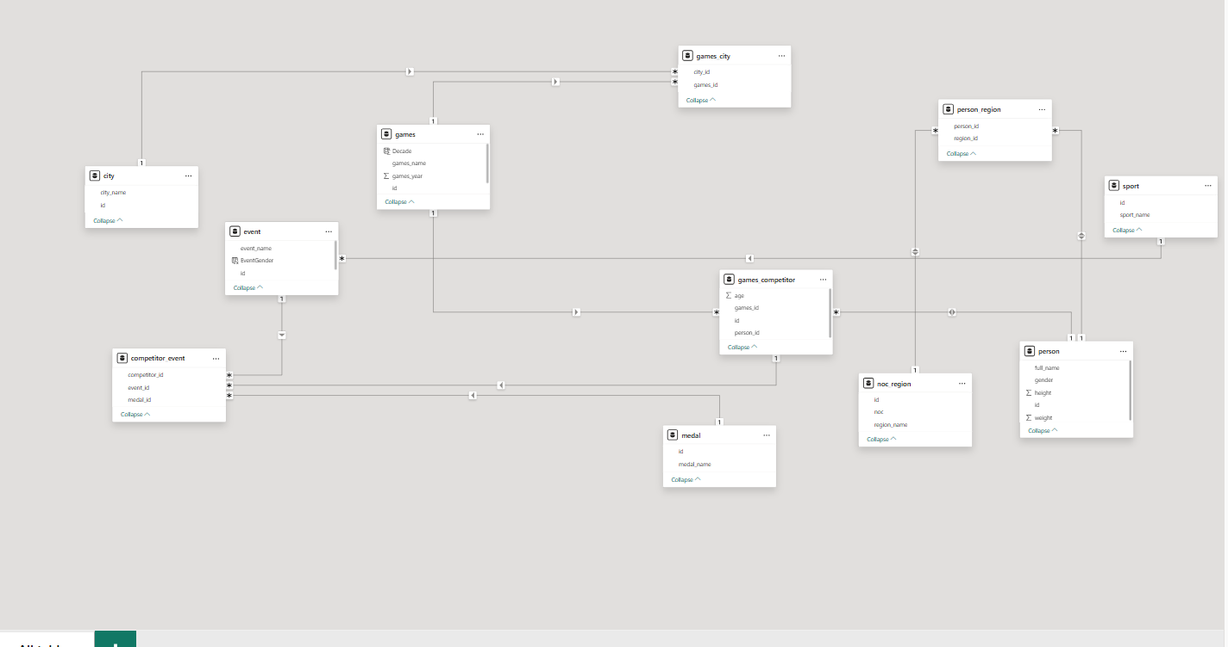

Power BI Problem Statement

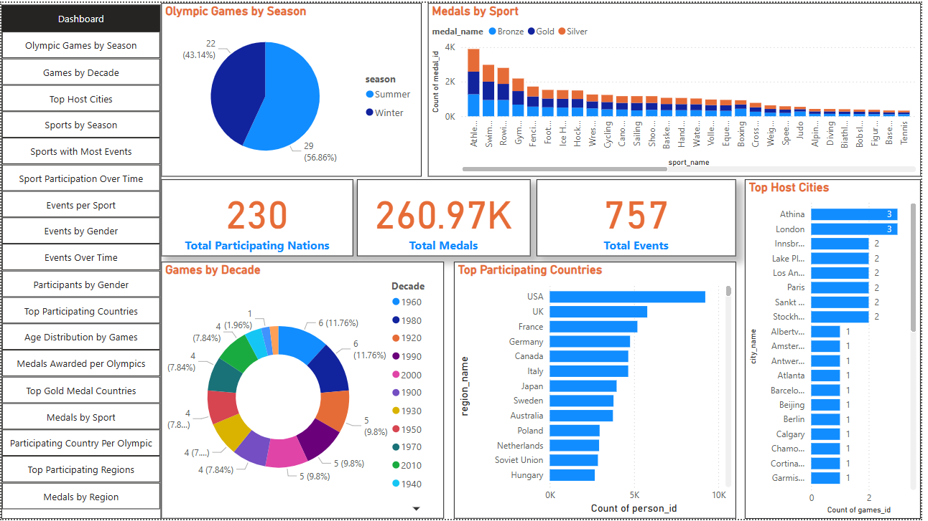

1. How many Olympic Games have been held in each season (Summer vs. Winter)?

**Conclusion:**  
The detailed analysis of Olympic Games history reveals a clear distinction between the frequency and prominence of the Summer and Winter Olympics. Since their inception, there have been 29 editions of the Summer Games and 22 editions of the Winter Games, as highlighted in the visual. This discrepancy is largely due to the Summer Olympics beginning much earlier, in 1896, while the Winter Olympics were introduced later, in 1924. The earlier start and broader appeal of summer sports have contributed to the Summer Games’ dominance in both frequency and global participation.

The pie chart visually underscores this distribution, with the Summer Games accounting for about 57% of all Olympic editions and the Winter Games making up the remaining 43%. The Summer Olympics have traditionally attracted more countries and athletes, reflecting the universal accessibility of summer sports and their historical significance. In contrast, the Winter Games, while prestigious, involve a narrower range of sports and participating nations, often influenced by geographic and climatic factors.

Overall, the data and visualizations confirm that the Summer Olympics have played a more central role in Olympic history, shaping the global perception of the Games and continuing to draw the largest share of international attention and participation.

1. What is the distribution of games across different decades?

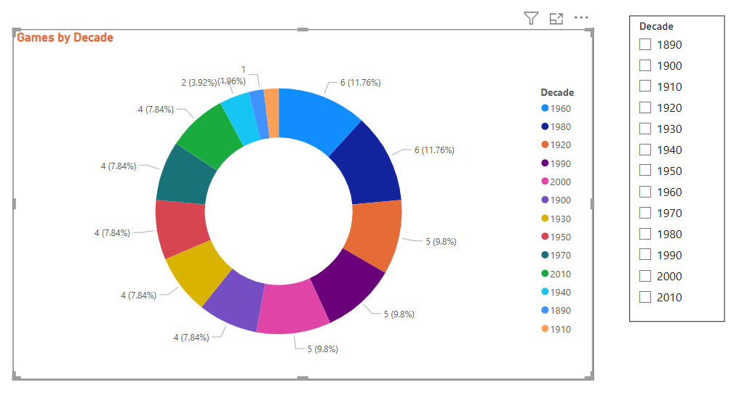

**Conclusion:**

The donut chart visualizes the distribution of Olympic Games across different decades, revealing several key trends in Olympic history. Most decades since the 1920s have hosted between four and six Olympic Games, reflecting the regular scheduling of both Summer and Winter editions. The 1960s and 1980s stand out with the highest number of Games (six each), which aligns with the established four-year cycle and the addition of Winter Games as a regular event starting in 1924. Earlier decades, such as the 1890s and 1900s, have notably fewer Games, primarily due to the Olympics’ later start and interruptions caused by global events like the World Wars, which led to cancellations in the 1910s and 1940s.

This even distribution in more recent decades demonstrates the stability and resilience of the Olympic movement, despite occasional challenges such as political boycotts or the COVID-19 pandemic, which led to the postponement of the 2020 Games. The data also reflects the growing importance and global reach of the Olympics, as the number of events and participating nations has expanded over time. Overall, the chart highlights how the Olympics have become a consistent and celebrated global tradition, adapting to world events while maintaining a regular and inclusive schedule for athletes and fans worldwide.

1. Which cities have hosted the most Olympic Games?

**Conclusion:**

The analysis of Olympic host cities reveals that London and Athens (Athina) top the list, each having hosted the Olympic Games three times, as reflected in the provided bar chart. London’s three editions (1908, 1948, and 2012) make it the most frequent host in Olympic history, with Paris set to join this group after the 2024 Games. Other cities such as Innsbruck, Lake Placid, Los Angeles, Paris, Sankt Moritz, and Stockholm have each hosted the Games twice, demonstrating their enduring significance and readiness to stage such a major international event.

This pattern highlights a tradition of returning to established cities with proven infrastructure, experience, and global appeal. Hosting the Olympics multiple times often brings lasting benefits to these cities, including improved sports facilities, increased tourism, and enhanced international reputation. However, the list also shows a broad geographic spread, with numerous cities hosting only once, reflecting the Olympic movement’s commitment to global representation and inclusivity over time.

Overall, the data underscores both the prominence of certain world cities in Olympic history and the evolving effort to diversify host locations, balancing tradition with the goal of engaging new regions and audiences worldwide.

1. What is the distribution of sports between Summer and Winter Olympics?

**Conclusion:**

The tree map visual and supporting data highlight a significant difference in the distribution of sports between the Summer and Winter Olympics. The Summer Olympics feature a much broader range of sports, with disciplines like athletics, swimming, cycling, and gymnastics occupying the largest segments, reflecting their prominence and the high number of events and participants they attract. In contrast, the Winter Olympics include far fewer sports, mainly focused on ice and snow-based disciplines such as skiing, skating, biathlon, and bobsleigh, which are popular in regions with suitable climates.

This disparity is rooted in both historical development and geographic accessibility: the Summer Games began in 1896 with a variety of widely practiced sports, while the Winter Games, introduced in 1924, have remained more specialized due to climatic requirements and a smaller pool of participating nations. As a result, the Summer Olympics consistently offer more sports, events, and opportunities for global participation, drawing over 200 countries, compared to about 90 in the Winter Games.

Overall, the data and visualizations clearly illustrate that the Summer Olympics dominate in terms of sport diversity and global reach, while the Winter Olympics maintain a focused program centred on traditional winter sports. This distribution underscores the broader appeal and inclusivity of the Summer Games, as well as the unique cultural and geographic identity of the Winter edition.

1. Which sports have the highest number of events in the Olympics?

**Conclusion:**

The analysis of Olympic sports by event count, as shown in the visual, highlights that Athletics and Swimming stand out as the sports with the highest number of events, each offering 83 distinct competitions. These two sports have long been central to the Olympic program, providing a wide range of opportunities for athletes and contributing significantly to the total medal tally. Shooting and Cycling also feature prominently, with 54 and 44 events respectively, followed by sports like Sailing, Wrestling, and Gymnastics, which each offer between 27 and 37 events.

This distribution reflects the diversity and complexity of certain sports, particularly those with multiple disciplines or weight classes, such as Athletics (track, field, road events) and Swimming (various strokes and distances). In contrast, many other sports, including newer or more specialized disciplines like Beach Volleyball or Curling, have only a handful of events, indicating a narrower competitive field.

The dominance of Athletics and Swimming in terms of event numbers not only makes them focal points for athletes and spectators but also means they play a crucial role in shaping overall medal standings and national Olympic strategies. This trend underscores the enduring popularity and global reach of these foundational Olympic sports, while also illustrating the evolving nature of the Games as new sports and events are periodically introduced or expanded.

1. How has the participation in each sport evolved over time

**Conclusion:**

The provided visual illustrates how participation in various Olympic sports has evolved over time, revealing distinct trends for each discipline. For example, Archery shows a steady and significant increase in athlete participation, especially from the mid-20th century onward, reflecting its growing popularity and the expansion of events. Alpine Skiing also demonstrates consistent growth, with notable peaks and some fluctuations, likely influenced by the addition of new events and changes in Olympic scheduling. In contrast, sports like Aeronautics and Alpinism display brief appearances with limited participation, indicating they were either demonstration sports or had a short-lived presence in the Olympic program.

These patterns align with broader Olympic trends: as the Games have expanded, more events and sports have been introduced, and global participation has increased. Historical events such as world wars, changes in Olympic policies, and the introduction of new disciplines have all contributed to fluctuations in participation numbers. The data also reflects the impact of social and cultural shifts, such as the inclusion of more women and athletes from diverse regions over time. Overall, the visualization highlights the dynamic and evolving nature of Olympic sport participation, shaped by both internal developments and broader historical contexts.

1. How many events are there in each sport?

**Conclusion:**

The analysis of Olympic sports reveals that each sport features a unique number of events, reflecting its diversity and structure. For example, Alpine Skiing, as shown in the provided visual, consists of 10 events—five for men and five for women—including Combined, Downhill, Giant Slalom, Slalom, and Super G for each gender1. This balanced distribution highlights the commitment to gender parity and provides multiple medal opportunities within a single sport.

Across the Olympic program, the number of events per sport can vary dramatically. Major sports like Athletics and Swimming have the highest number of events, with over 40 each, due to their multiple disciplines and categories (such as different distances, styles, or weight classes). In contrast, some sports, especially those recently introduced or with specialized appeal, may have only a handful of events. The International Olympic Committee (IOC) regularly reviews and updates the event list, adding new disciplines or modifying existing ones to reflect trends, popularity, and inclusivity.

This structure allows the Olympics to showcase both traditional and emerging sports, ensuring a dynamic and inclusive competition. The event breakdown within each sport not only shapes athlete preparation and national strategies but also enhances the Games’ appeal to a global audience by offering a wide variety of competitions and medal opportunities.

1. What is the distribution of events by gender (Men, Women, Mixed)?

**Conclusion:**

The donut chart clearly shows a significant gender gap in Olympic events, with 71.67% of events for men (187.04K) and only 28.33% for women (73.93K)1. This distribution reflects the historical dominance of male events in the Olympics; a pattern rooted in the early exclusion of women from most competitions and slow progress toward equality over the decades. While recent Olympic editions, especially Paris 2024, have achieved near gender parity in both athlete participation and the number of events, the overall historical data still highlights a substantial imbalance.

Efforts by the International Olympic Committee (IOC) have accelerated in recent years, introducing more women’s and mixed-gender events and setting quotas to ensure balanced representation. The addition of mixed events and the drive for equal medal opportunities have narrowed the gap, but the legacy of past disparities remains evident in cumulative event totals. This progress is especially visible in recent Games, where the number of women’s events and mixed competitions has grown significantly, and some upcoming Olympics are projected to feature more women’s events than men’s for the first time.

In summary, while the historical distribution of Olympic events by gender has been heavily skewed toward men, ongoing reforms and recent milestones are steadily moving the Games toward true gender equality, as reflected in recent and upcoming Olympic programs

1. How has the number of events changed over time?

**Conclusion:**

The number of Olympic events has changed dramatically over time, reflecting the Games’ evolution and expansion. In the inaugural 1896 Athens Olympics, there were just 43 events, all for male competitors. Over the decades, the program steadily grew, with new sports and disciplines added—such as gymnastics, swimming, and athletics—each introducing multiple events and categories. The addition of women’s events and, more recently, mixed-gender competitions has further increased the event count, promoting greater inclusivity and diversity.

The data table for wrestling, for example, demonstrates how a single sport can encompass dozens of events across different weight classes and styles for both men and women, contributing significantly to the overall event total (over 260,000 entries in the dataset, reflecting every instance of participation)1. The total number of events at each Olympiad has climbed from under 50 in the early 20th century to over 400 in recent Summer Games, with the 2020 Tokyo Olympics featuring 408 events across 35 sports.

This growth is driven by the International Olympic Committee’s efforts to modernize the Games, respond to global sporting trends, and ensure broader representation. The result is a richer, more varied Olympic program that continues to adapt to the changing landscape of international sport, offering more opportunities for athletes and nations than ever before.

10 What is the distribution of participants by gender?

**Conclusion:**

The pie chart reveals a significant historical gender gap in Olympic participation, with 73.12% of participants being men (131.8K) and only 26.88% women (48.45K)1. This distribution reflects the longstanding male dominance in the Games, rooted in the early exclusion of women from most competitions and the gradual inclusion of female athletes over the past century. While recent Olympics, especially Paris 2024, have achieved full gender parity in athlete numbers, the cumulative data still highlights this legacy imbalance. The steady increase in female participation over time demonstrates the impact of deliberate reforms and the Olympic movement’s commitment to equality, but also underscores the importance of ongoing efforts to ensure balanced representation across all sports and roles within the Olympic community.

11 Which countries have the highest number of participants in the Olympics?

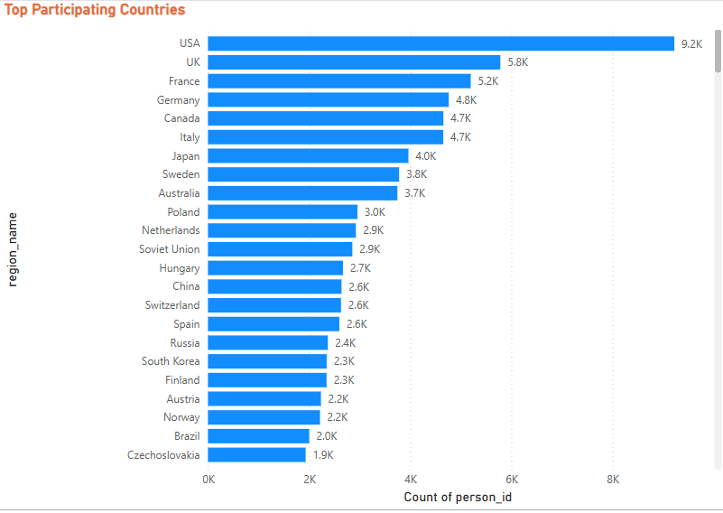

**Conclusion:**

The bar chart clearly shows that the United States has the highest number of Olympic participants, with 9,200 athletes, far surpassing other countries1. The UK and France follow, with 5,800 and 5,200 participants respectively, while Germany, Canada, and Italy each have close to 4,700–4,800 athletes. Other nations like Japan, Sweden, and Australia also have strong representation, each contributing thousands of participants over the history of the Games. This pattern reflects the strong sports infrastructure, investment, and long-standing Olympic traditions in these countries, which consistently enable them to send large delegations to both Summer and Winter Olympics. Countries such as Poland, the Netherlands, the Soviet Union, and Hungary round out the top twenty, highlighting the global reach and competitive spirit of the Olympics. Overall, the data underscores how a select group of nations have played a dominant role in shaping Olympic participation, leveraging their resources and sporting culture to maintain a significant presence at the Games.

12 How does the age distribution of participants vary across different games?

**Conclusion:**

The line chart depicting age distribution by Olympic Games year reveals several important trends in athlete participation. In the early years of the Olympics, average participant age fluctuated significantly, with notable peaks above 30 years around the 1930s and dips below 24 in the early 1900s. This variability can be attributed to the evolving nature of the Olympic program, the introduction of new sports, and the impact of world events such as wars. From the 1950s onward, the average age began a gradual decline, reaching its lowest point in the 1980s. Since then, the average age has stabilized, hovering between 25 and 27 years in recent decades.

This stabilization aligns with broader research showing that most Olympic athletes are between 20 and 30 years old, with the overall mean age for men at 27 and for women at 26.2 years. Sports such as gymnastics and swimming tend to feature younger athletes, while disciplines like equestrian, sailing, and shooting often include older competitors. The consistency in average age in recent Games reflects advances in athlete development, sports science, and the increasingly professional nature of Olympic preparation. Overall, the data highlights both the diversity and the evolving age profile of Olympic athletes, shaped by sport-specific demands, gender differences, and historical context.

13. How many medals have been awarded in each Olympics?

**Conclusion:**

The bar chart illustrates a clear upward trend in the number of medals awarded at each Olympic Games, especially in the summer editions. Recent Summer Olympics, such as 2008, 2016, and 2004, each saw over 2,000 medals awarded, reflecting the expansion of sports and events over time. In contrast, earlier Games and most Winter Olympics awarded far fewer medals, with the earliest Winter Games distributing just over 100 medals each. This growth is driven by the increasing number of sports, events, and participating athletes, as well as the introduction of more gender categories and mixed events in recent decades. The data also highlights the difference between Summer and Winter Games, with summer editions consistently awarding more medals due to their larger scale and broader global participation. Overall, the chart underscores the dynamic evolution of the Olympics, with each edition adapting to new sports trends and global developments, resulting in a richer and more inclusive medal landscape for athletes worldwide.

14 Which countries have the highest number of gold medals?

**Conclusion:**

The data and visualizations make it clear that the United States leads all countries by a wide margin in the number of gold medals won at the Olympics, with a total of 2,533 golds. The Soviet Union ranks second with 1,135 gold medals, followed by Germany with 843, and the United Kingdom with 658. Other countries with significant gold medal counts include Italy, France, Sweden, Russia, and Canada, each with several hundred golds to their name. This dominance by a handful of countries reflects their strong sporting infrastructure, investment in athlete development, and long-standing Olympic traditions, which have enabled them to consistently field large, competitive teams across both Summer and Winter Games. The data also underscores the historical influence of geopolitical factors, as seen in the high medal counts of former nations like the Soviet Union and East Germany. Overall, the distribution of gold medals highlights how a select group of nations have shaped Olympic history, setting benchmarks for sporting excellence and inspiring global competition.

15 How does the medal distribution vary across different sports?

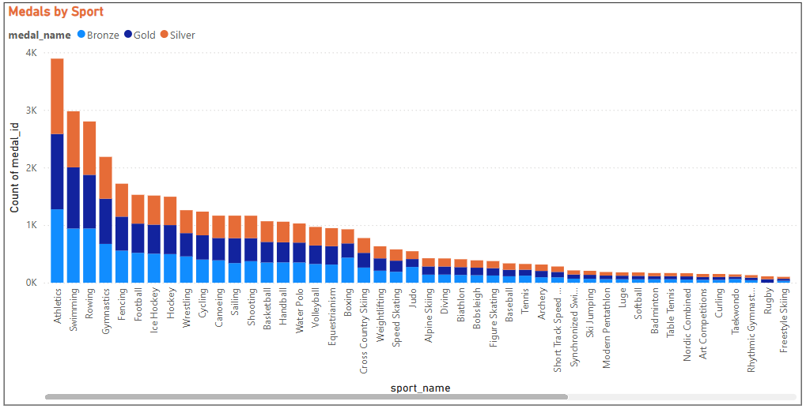

**Conclusion:**

The stacked bar chart of Olympic medals by sport reveals a striking variation in medal distribution across different disciplines. Athletics and Swimming stand out as the most prolific sports, each awarding nearly 4,000 and 3,000 medals respectively, due to their extensive range of events and categories. Rowing, Gymnastics, Fencing, and Football also contribute significantly to the overall medal count, reflecting their long-standing presence and popularity within the Olympic program. In contrast, many sports, particularly those introduced more recently or with a narrower competitive field—such as Rugby, Freestyle Skiing, and Rhythmic Gymnastics—have awarded far fewer medals.

This disparity is rooted in the structure of each sport: disciplines with multiple events, weight classes, or styles (like Athletics and Swimming) naturally generate more medal opportunities, while others remain more limited. The chart also highlights the balance among gold, silver, and bronze medals within each sport, emphasizing the consistency of medal awarding practices. Ultimately, the distribution underscores the central role of a few major sports in shaping Olympic medal tallies and national strategies, while also illustrating the diversity and evolving landscape of the Games as new sports are added and others evolve or decline in prominence

16 How many regions or NOCs participate in each Olympic Games?

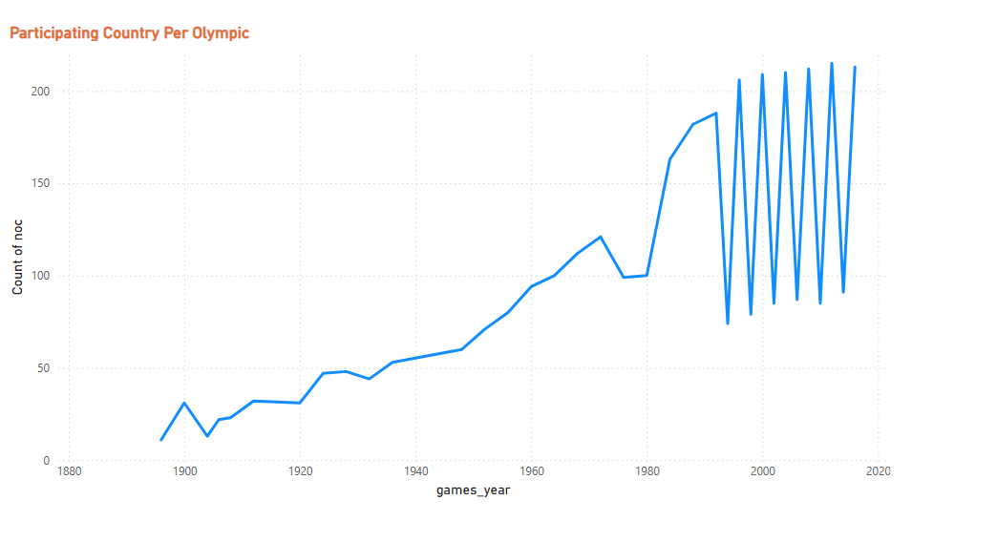

**Conclusion:**

The line chart illustrates the remarkable growth in the number of participating regions or National Olympic Committees (NOCs) at each Olympic Games since the late 19th century. In the early years, fewer than 20 NOCs took part, but this number steadily increased throughout the 20th century, reflecting the expanding global reach and inclusivity of the Olympic movement. Key milestones, such as decolonization, the emergence of new nations, and the end of geopolitical conflicts, contributed to significant jumps in participation, especially after World War II and during the late 20th century. By the 1980s, the number of NOCs surpassed 140, and in recent decades, participation has stabilized around 200, with the 2024 Paris Olympics expecting athletes from approximately 206 NOCs—the maximum recognized by the International Olympic Committee. The chart also shows occasional dips, often due to boycotts or political issues, but the overall trend is one of increasing diversity and representation. This growth underscores the Olympics’ role as a truly global event, uniting nations from all continents and providing a platform for both established and emerging countries to showcase their athletic talent and national identity on the world stage.

17 Which regions have the highest number of participants in the Olympics?

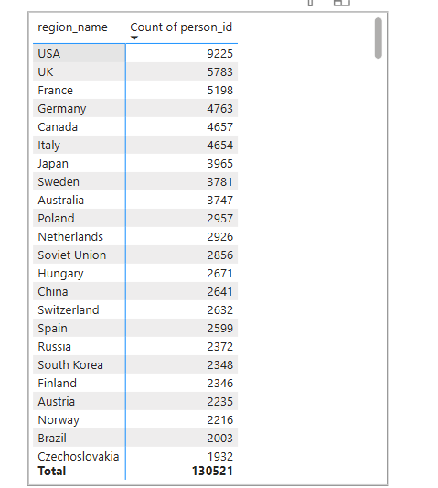

**Conclusion:**

The data table and supporting visuals clearly indicate that the United States has the highest number of Olympic participants, with 9,225 athletes, far surpassing all other regions. The UK and France follow, with 5,783 and 5,198 participants respectively, while Germany, Canada, and Italy each have over 4,600 athletes. Other countries such as Japan, Sweden, Australia, and Poland also feature prominently, each contributing thousands of participants to the Games. This pattern reflects the strong sports infrastructure, investment, and long-standing Olympic traditions in these countries, enabling them to consistently send large delegations to both Summer and Winter Olympics.

The dominance of these regions highlights the impact of economic resources, population size, and a deep-rooted sporting culture on Olympic participation. Additionally, historical and geopolitical factors, such as the legacy of the Soviet Union and Czechoslovakia, are evident in the high participant numbers from these now dissolved nations1. Overall, the data underscores how a select group of countries have played a leading role in shaping the Olympic landscape, leveraging their resources and commitment to sports to maintain a significant presence at the Games, while also reflecting the global diversity and reach of the Olympic movement.

18 What is the distribution of medals among different regions?

**Conclusion:**

The bar chart vividly illustrates the distribution of Olympic medals among different regions, highlighting a clear dominance by a few countries. The United States stands out as the most successful nation, amassing over 5,000 medals, followed by the Soviet Union, Germany, the UK, and France, each with substantial medal counts. These leading countries have consistently invested in sports infrastructure, athlete development, and international competition, enabling them to field large, competitive teams across both Summer and Winter Games. Other nations such as Italy, Sweden, Australia, and Russia also feature prominently, reflecting their strong Olympic traditions and sustained commitment to excellence.

The chart also reveals a steep drop-off after the top performers, with many countries earning significantly fewer medals, often due to smaller populations, limited resources, or less established sports programs. This global disparity underscores how economic strength, historical context, and national priorities shape Olympic success. Additionally, the distribution of gold, silver, and bronze medals within each region is relatively balanced, indicating consistent competitiveness at the highest level.

Overall, the data demonstrates that while the Olympic spirit is global, the distribution of medals remains concentrated among a select group of nations, reflecting both their sporting legacy and ongoing commitment to athletic achievement on the world stage.

EDA Problem Statement

Q1

Q2

